**Ideation Phase**

**Define the Problem Statements**

|  |  |
| --- | --- |
| Date | 16 June 2025 |
| Team ID | LTVIP2025TMID55634 |
| Project Name | Booknest: Where Stories Nestle |
| Maximum Marks | 2 Marks |

**Customer Problem Statement Template:**

Create a problem statement to understand your customer's point of view. The Customer Problem Statement template helps you focus on what matters to create experiences people will love.

A well-articulated customer problem statement allows you and your team to find the ideal solution for the challenges your customers face. Throughout the process, you’ll also be able to empathize with your customers, which helps you better understand how they perceive your product or service.

**Example:**

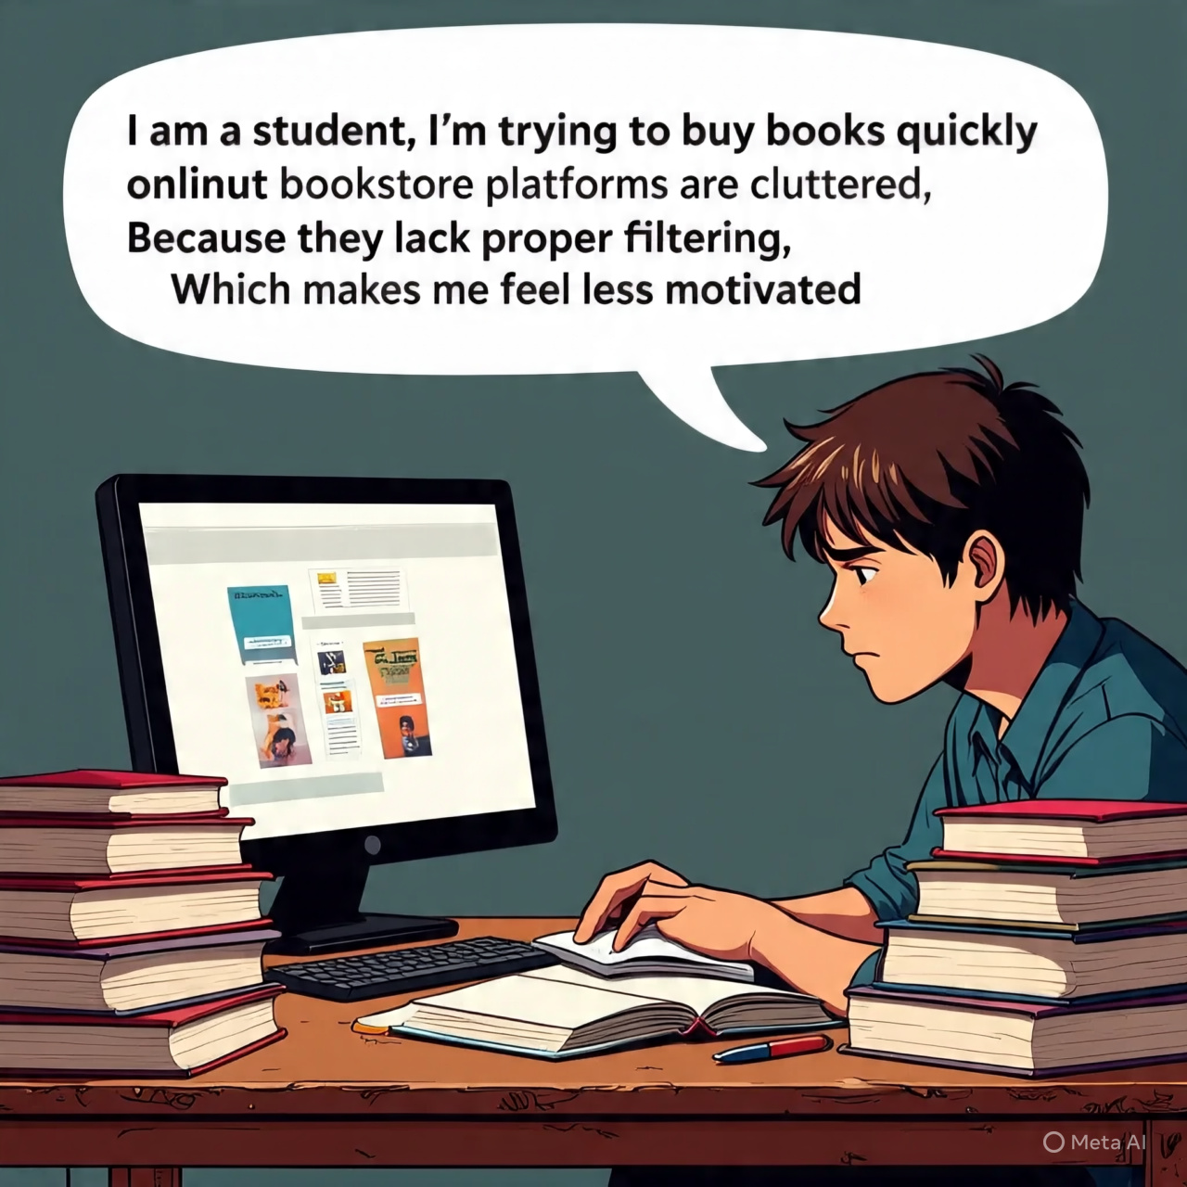

|  |  |  |  |  |  |
| --- | --- | --- | --- | --- | --- |
| **Problem Statement (PS)** | **I am (Customer)** | **I’m trying to** | **But** | **Because** | **Which makes me feel** |
| **PS-1** | A busy student who loves reading | Find and buy books quickly online | Most bookstore platforms are cluttered and time-consuming | They lack proper filtering, personalization, and smooth UX | Frustrated and overwhelmed |
| **PS-2** | An admin managing book inventory | Keep the online store updated with books, prices, and orders | Manual updates take time and often cause errors | There’s no efficient dashboard or automation | Drained and less motivated to maintain the site |